TWITTER DATABASE MANAGEMENT SYSTEM

NAME: Anurag Sai.Y

Roll No: 1602-21-737-009

Sec: IT-A

ABSTRACT:

The Twitter Database Management System is a software application designed to efficiently manage the vast amount of data generated by the Twitter social media platform. The system employs a variety of data management techniques, such as indexing, caching, and partitioning, to ensure fast and reliable access to the data. The system is scalable and can handle a large volume of data, making it suitable for use by large organizations or enterprises. Its features include user authentication, data backup, and recovery, as well as advanced search capabilities. The Twitter Database Management System is an essential tool for businesses and researchers seeking to analyze and extract valuable insights from Twitter data.

Requirement Analysis

**List of Tables:**

1. authentication

2. follow

3. block

4. tweet

5. retweets

6.messages

7.users

8.location

9.hashtag

ER DIAGRAMS

DDL COMANDS

Location Table:

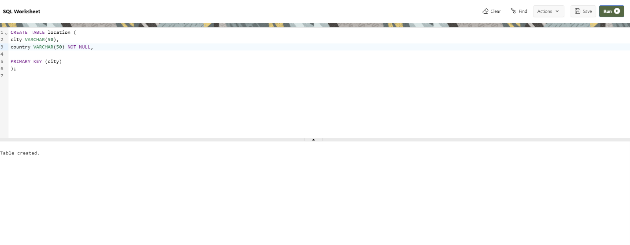

Users Table:

Authentication Table:

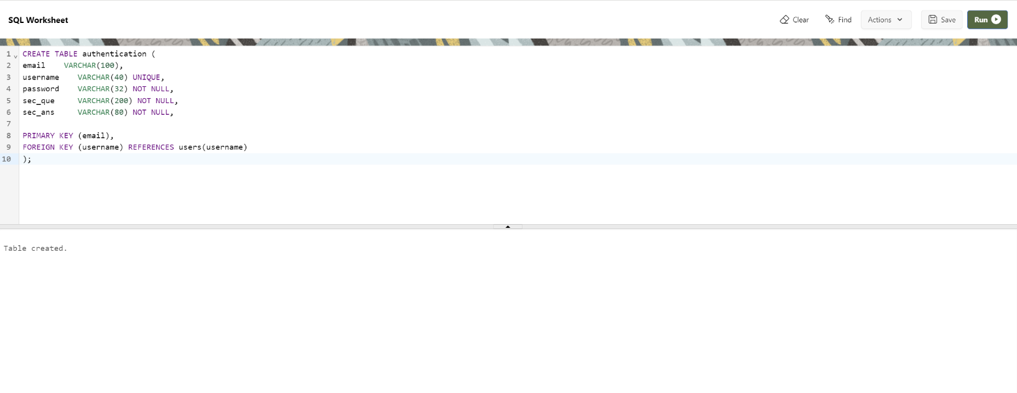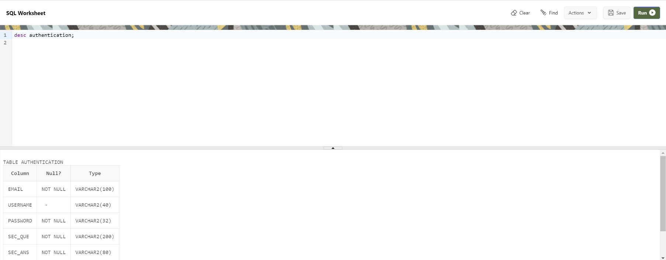

Follow Table:

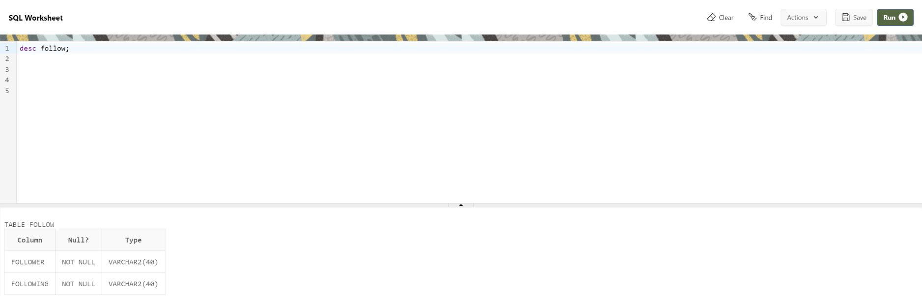

Block Table:

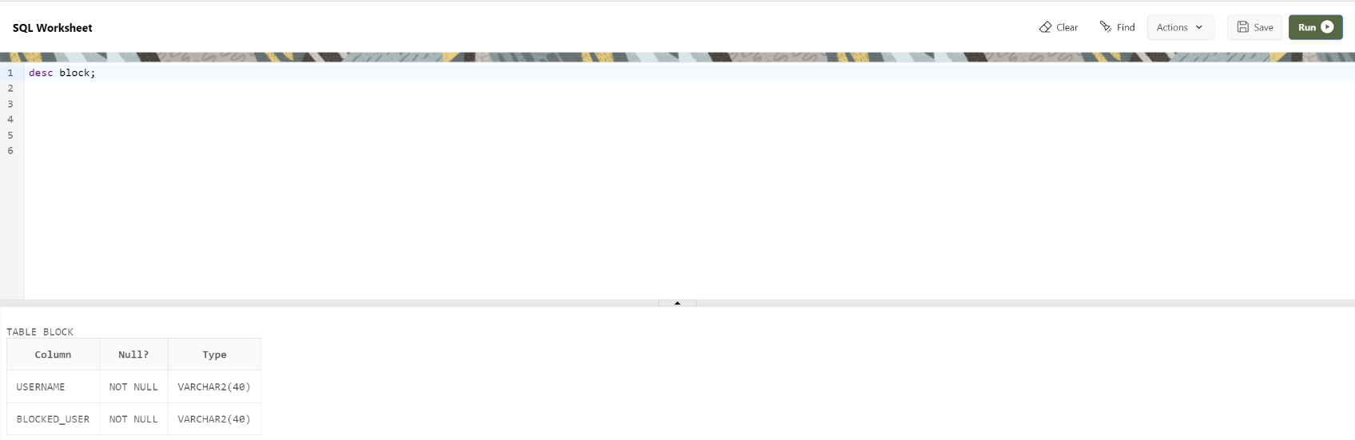

Tweet Table:

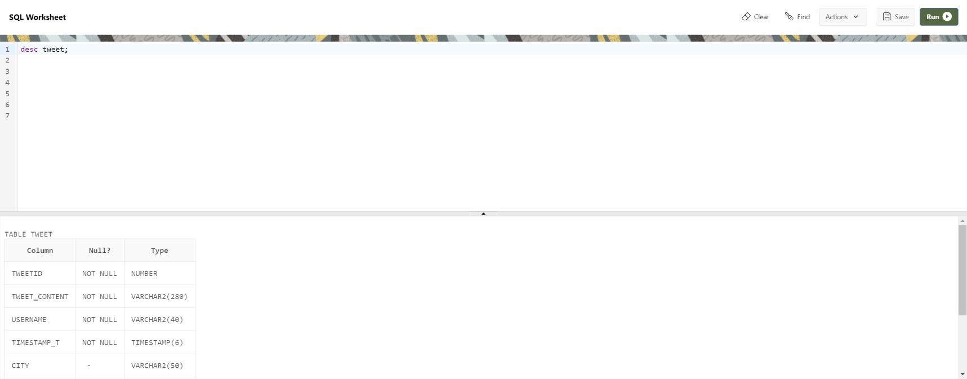

Hashtag Table:

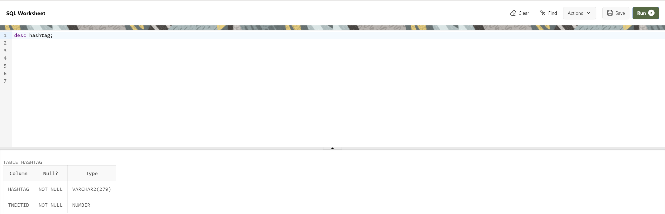

Retweets Table:

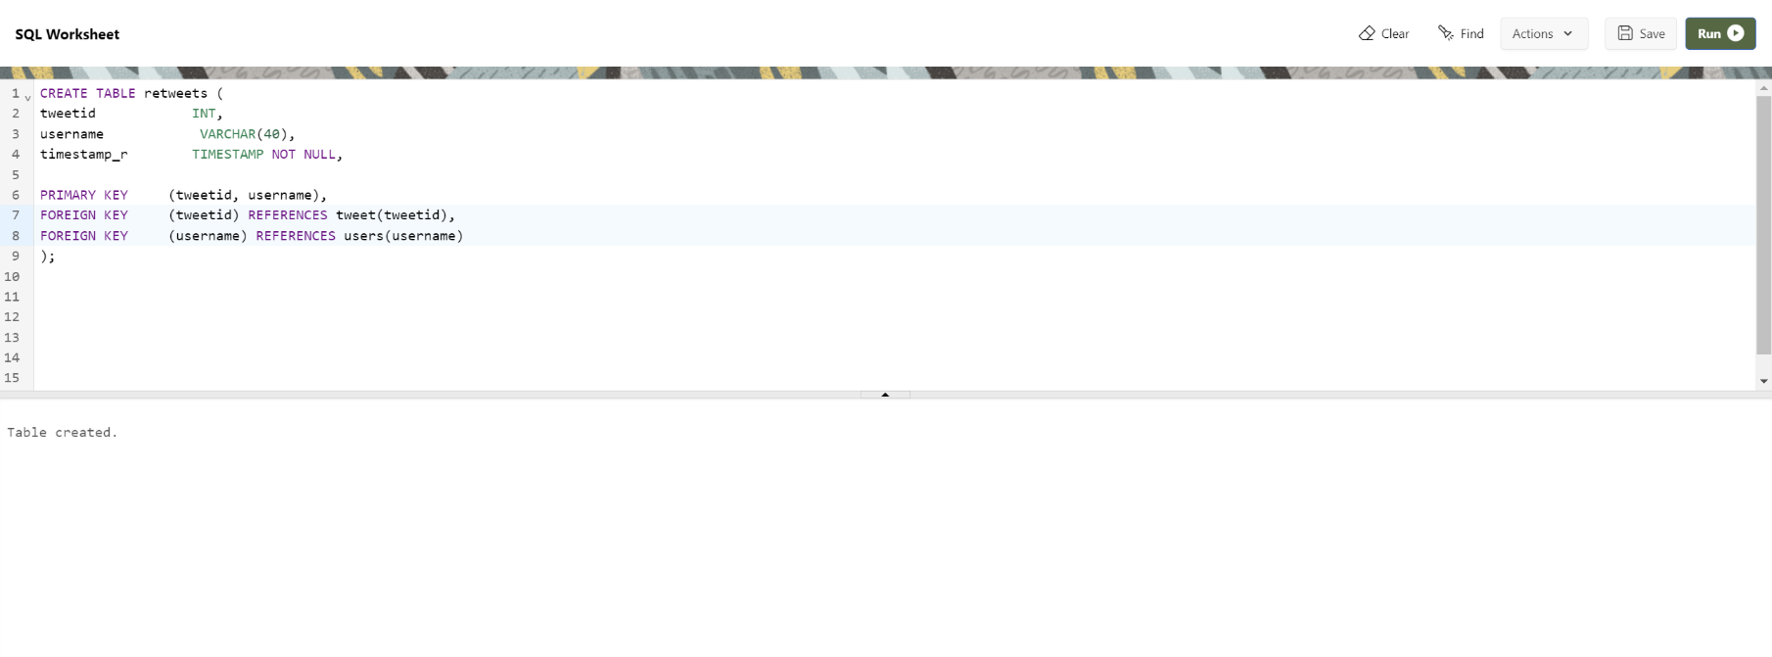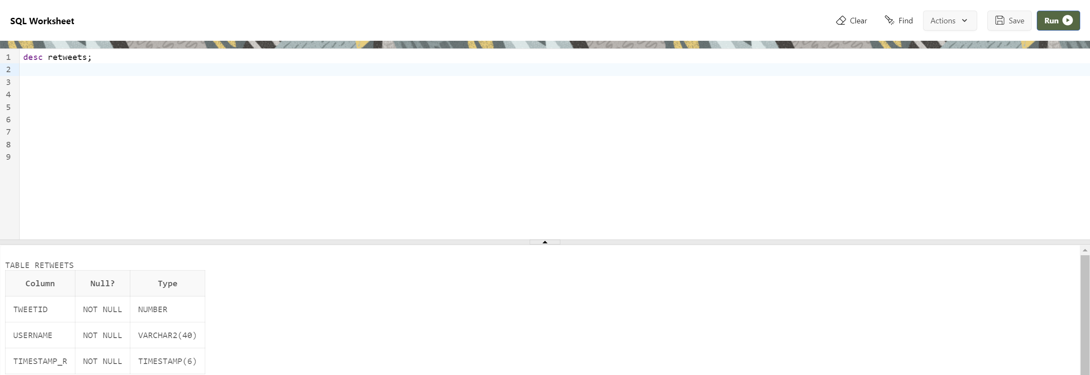

Likes Table:

Messages Table:

